**MIDDLETON CHENEY FOOTBALL CLUB**

**ANNUAL GENERAL MEETING**

**1982**

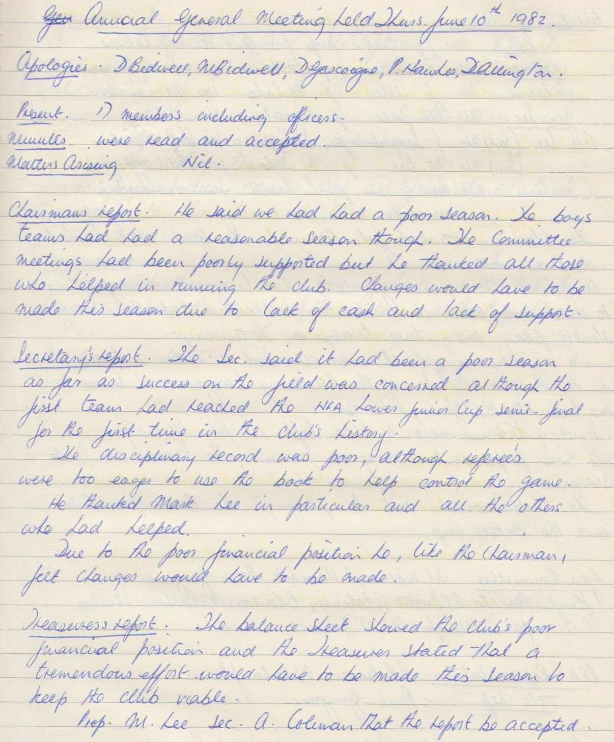

**Continued**

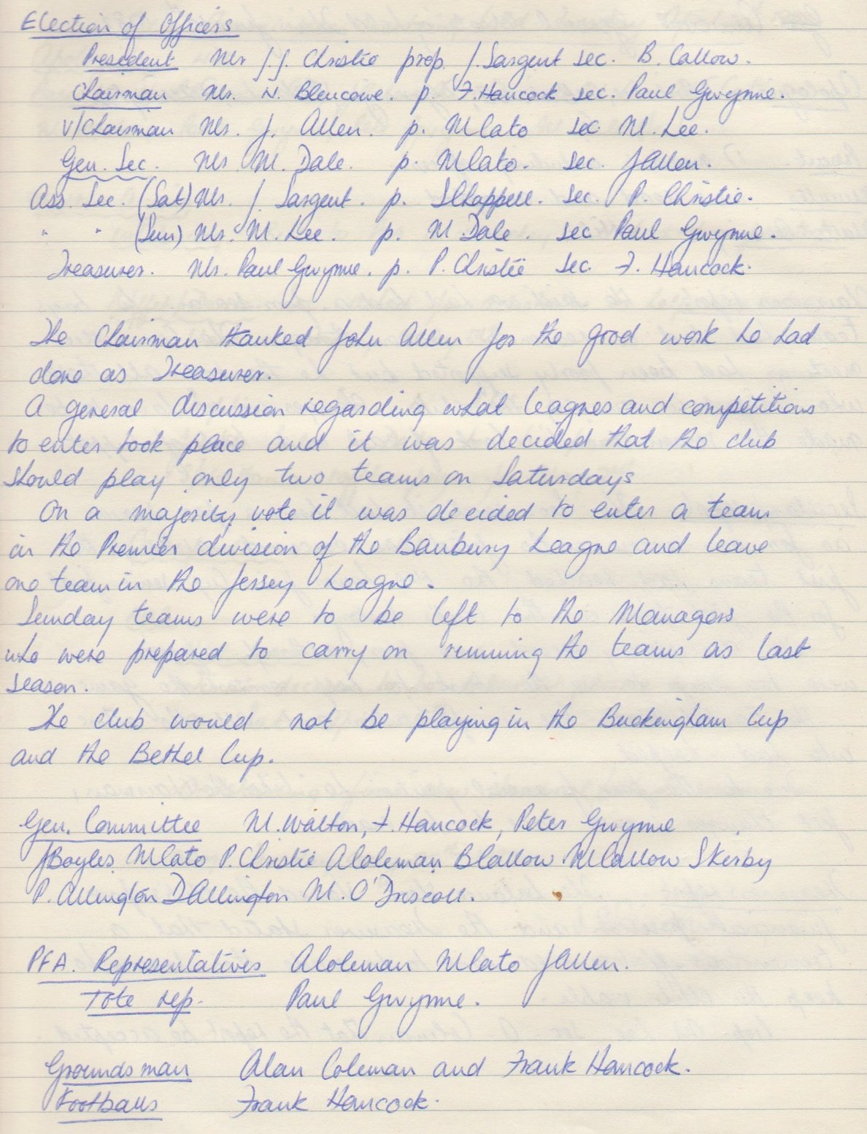**Continued**

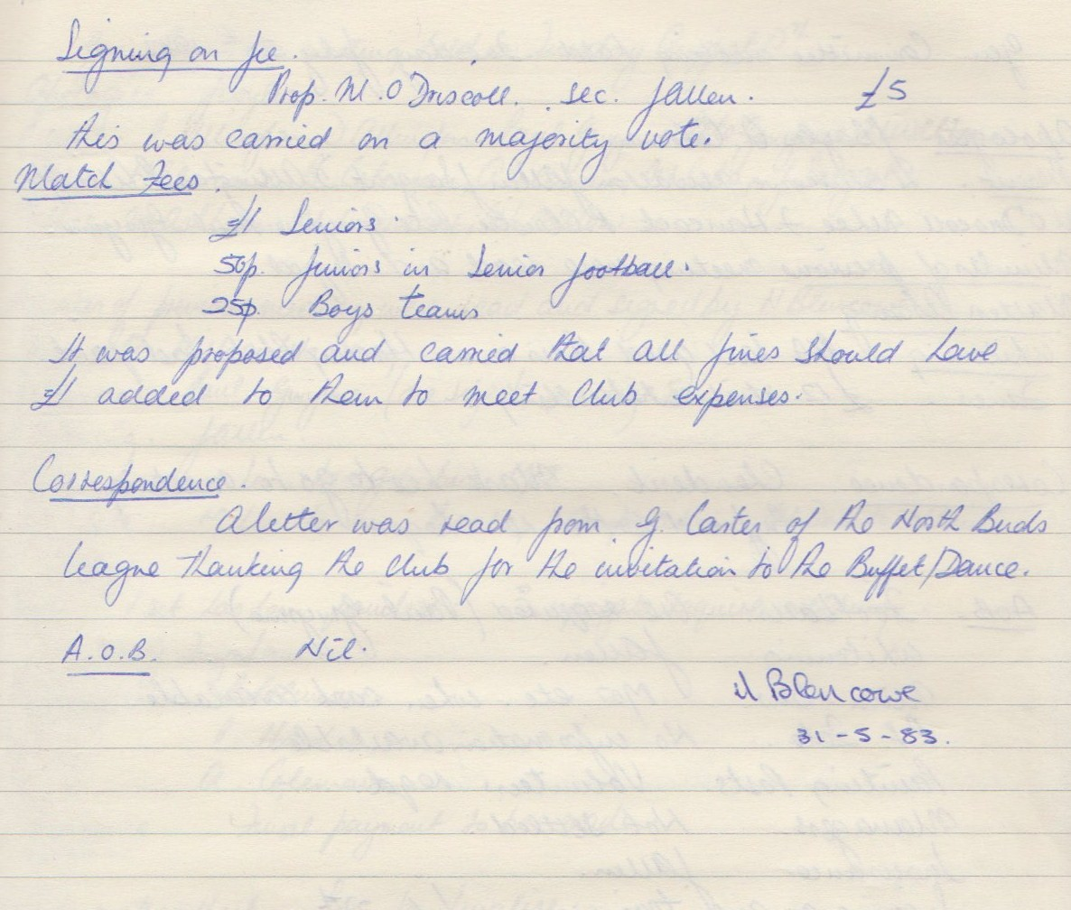

**General Committee Meeting**

**July 20th 1982**

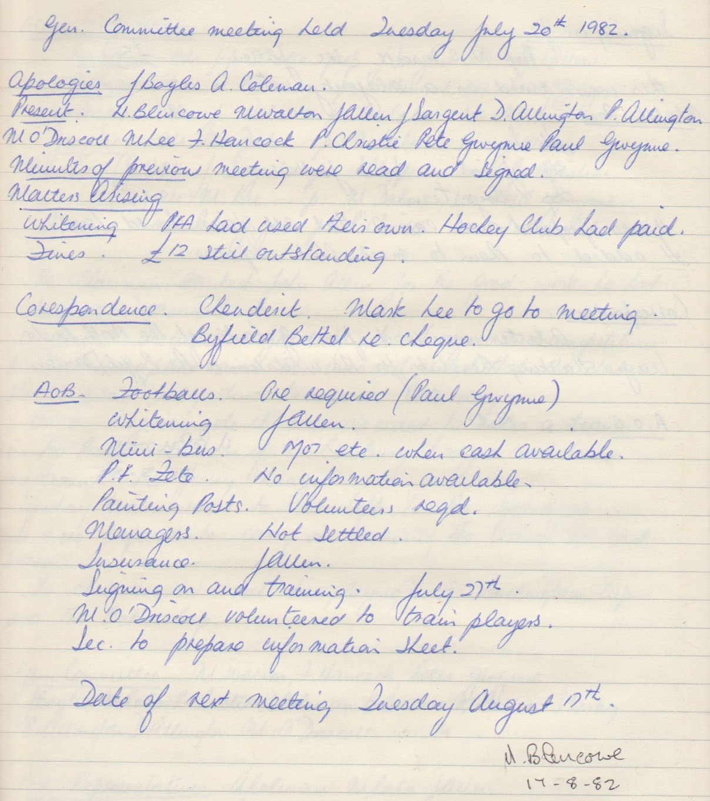

**General Committee Meeting**

**August 17th 1982**

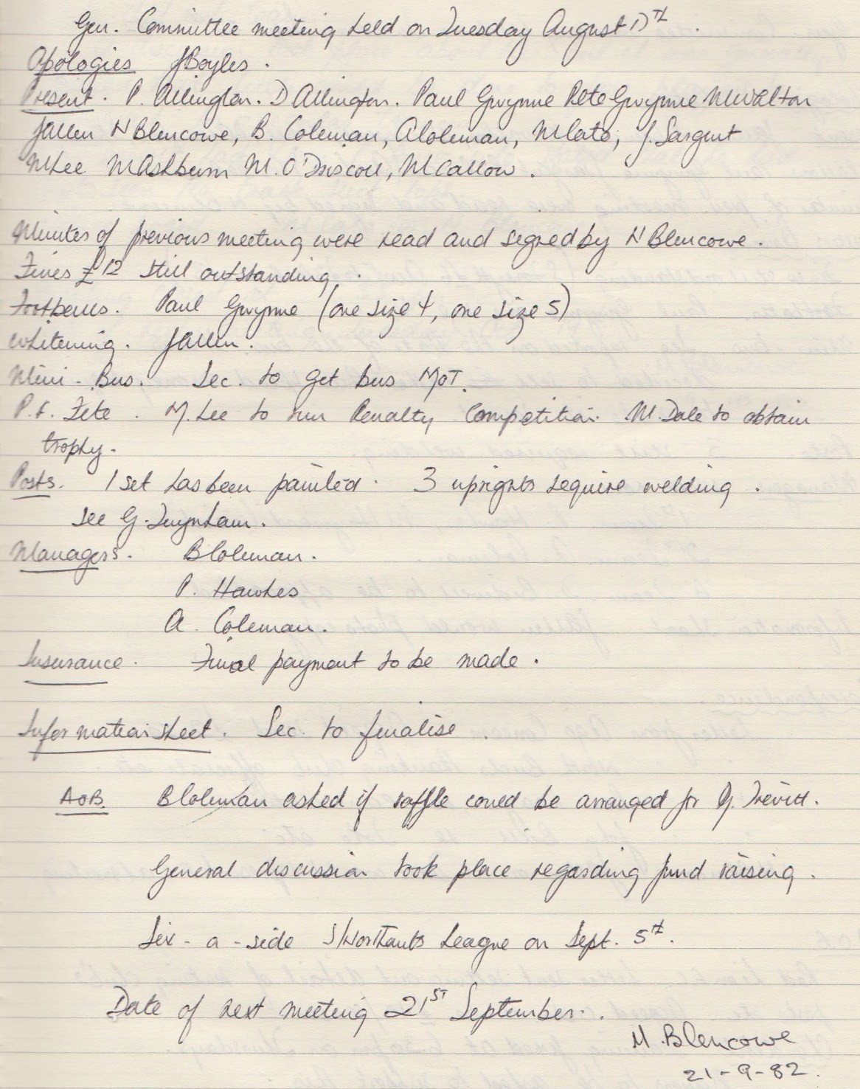

**General Committee Meeting**

**September 22nd 1982**

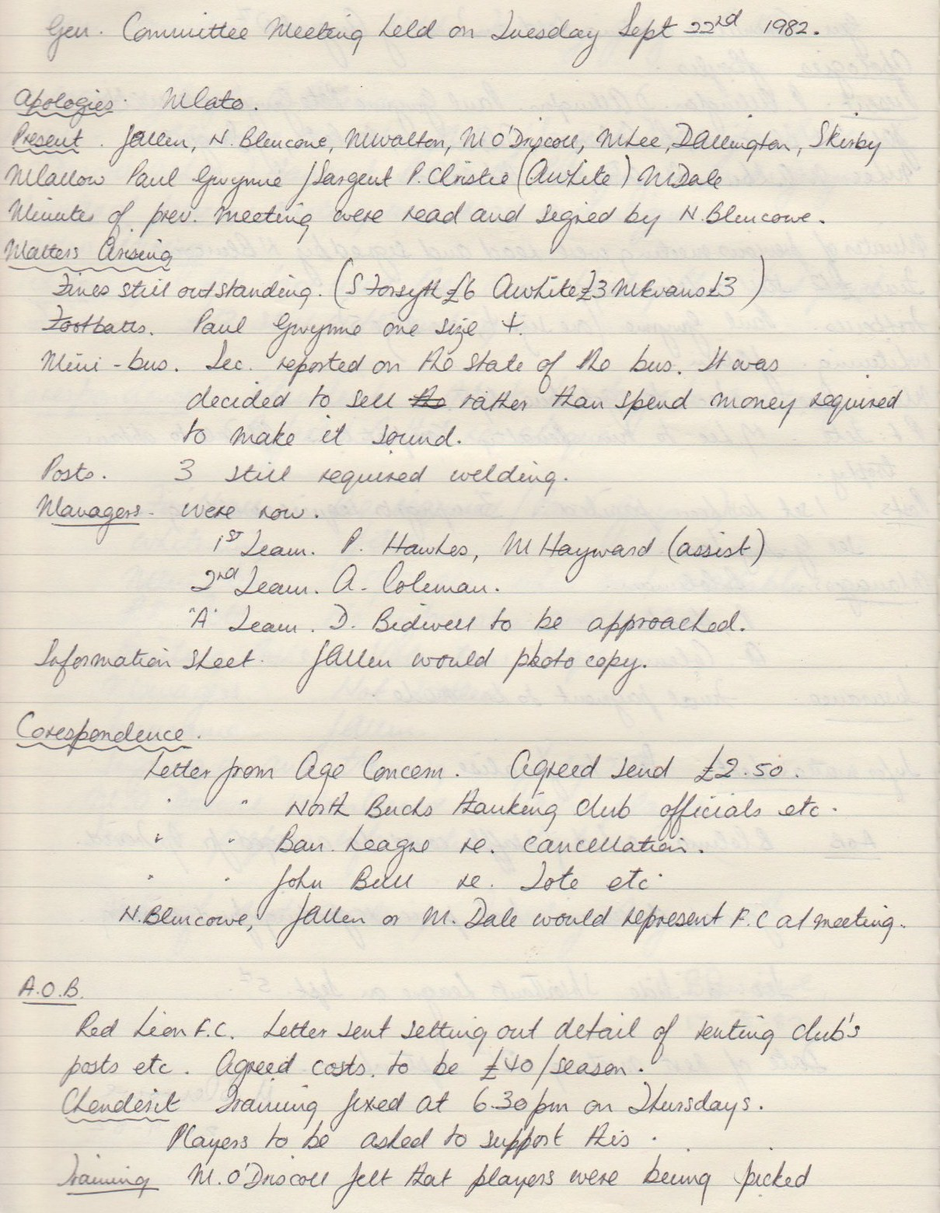

**Continued**

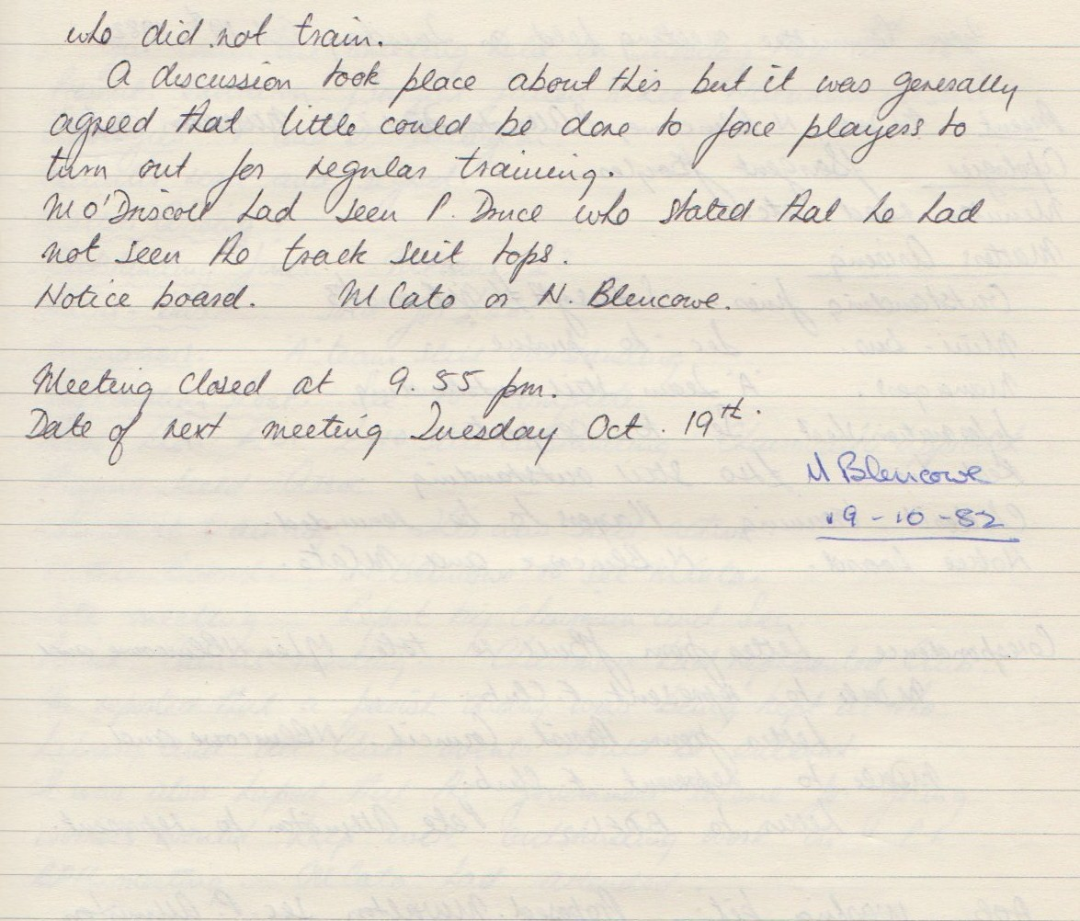

**General Committee Meeting**

**October 19th 1982**

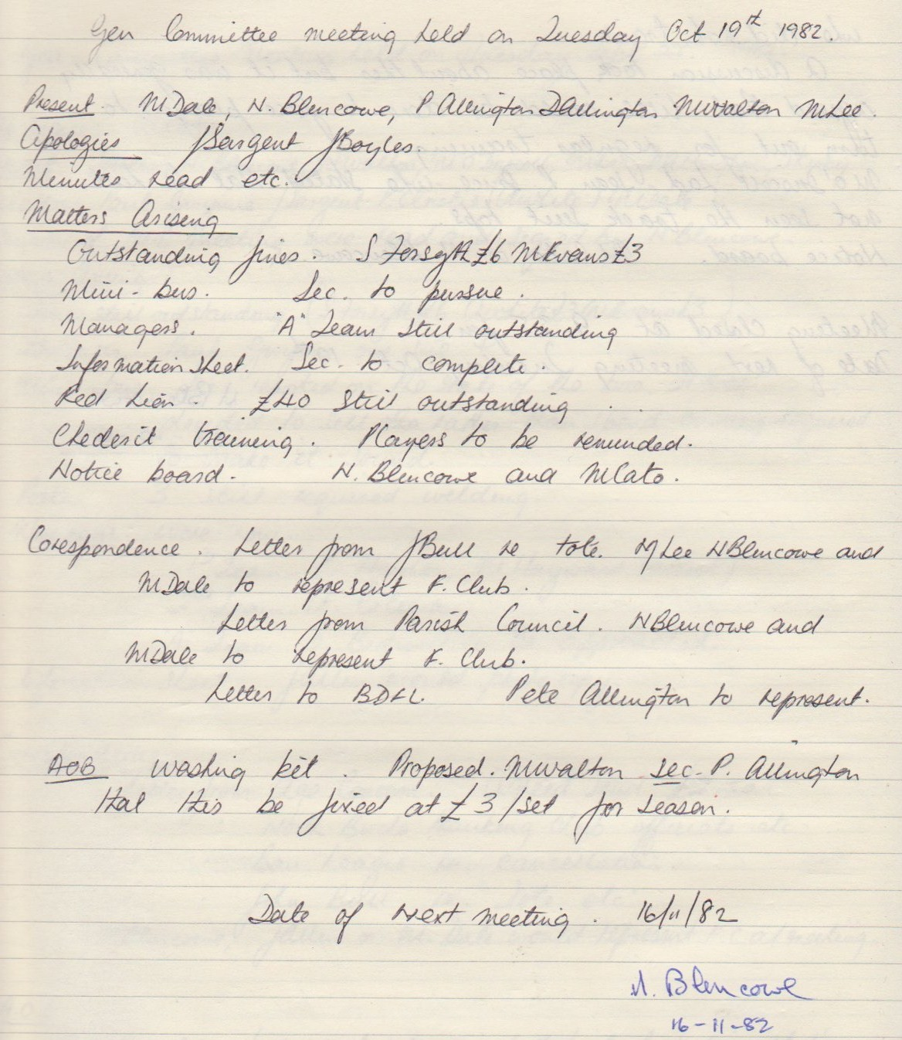

**General Committee Meeting**

**November 16th 1982**

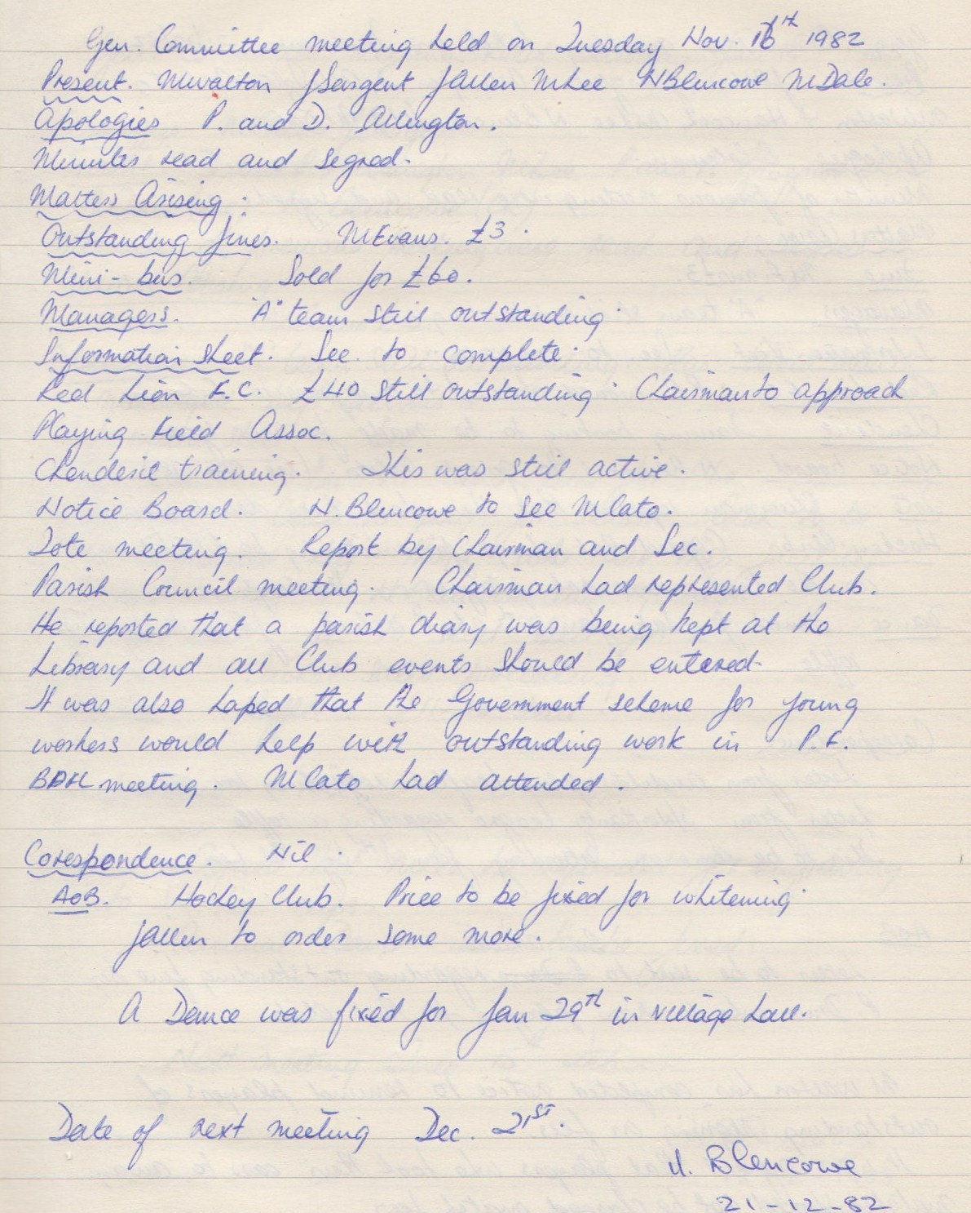

**General Committee Meeting**

**December 21st 1982**

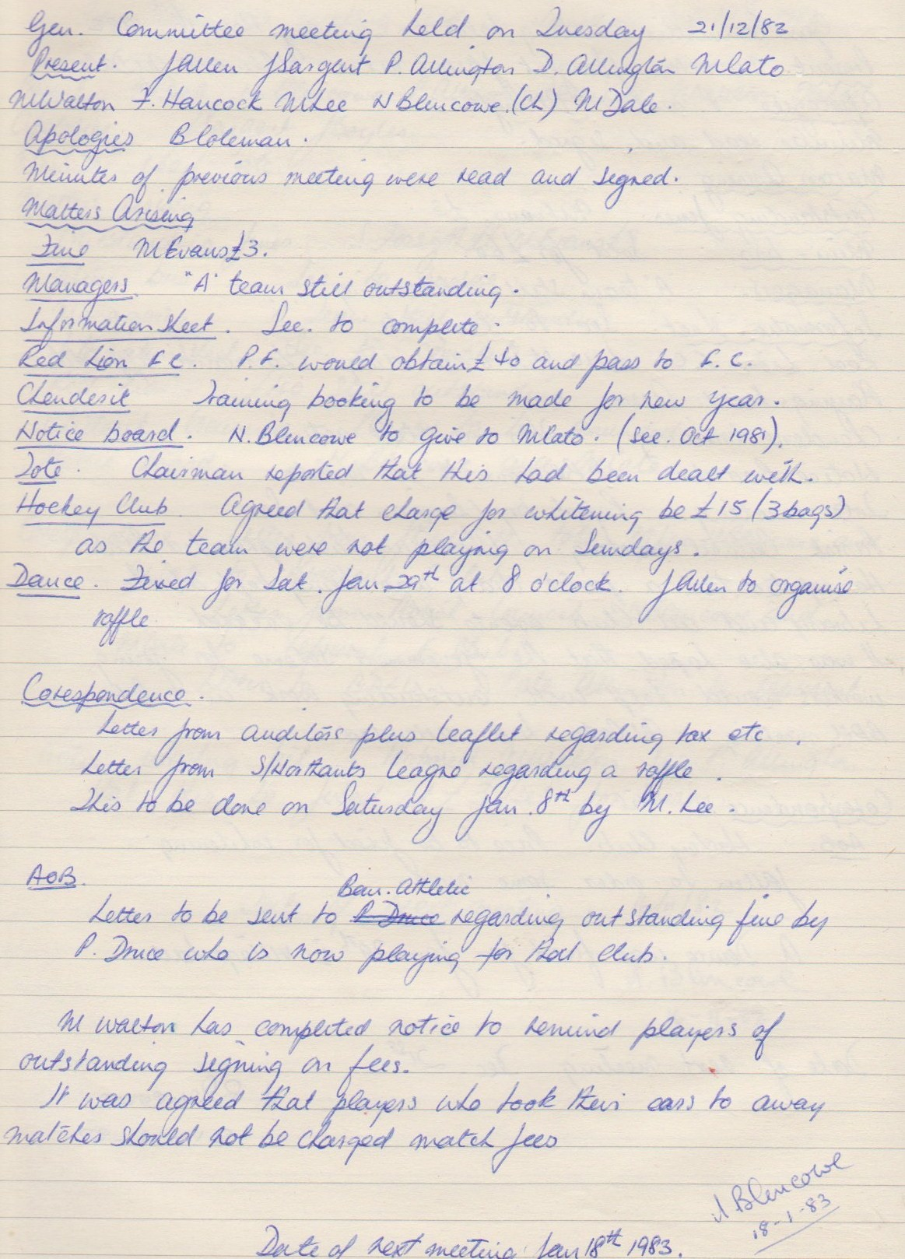

**General Committee Meeting**

**January 1983**

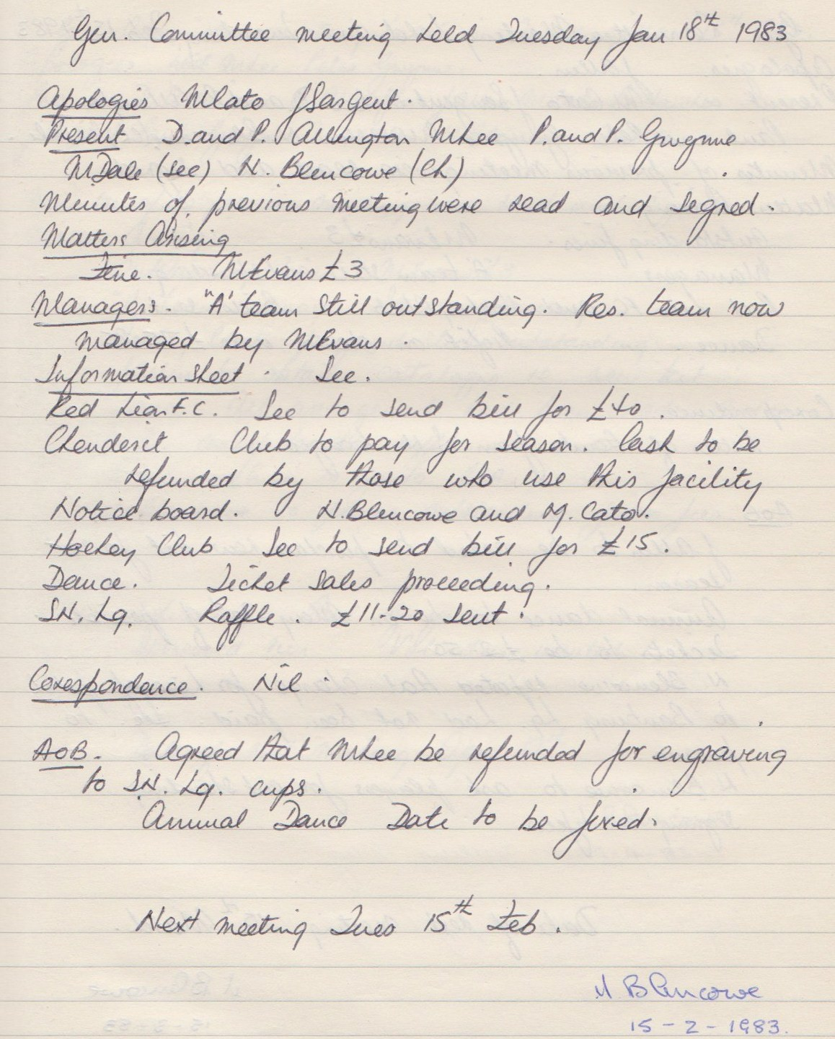

**General Committee Meeting**

**February 15th 1983**

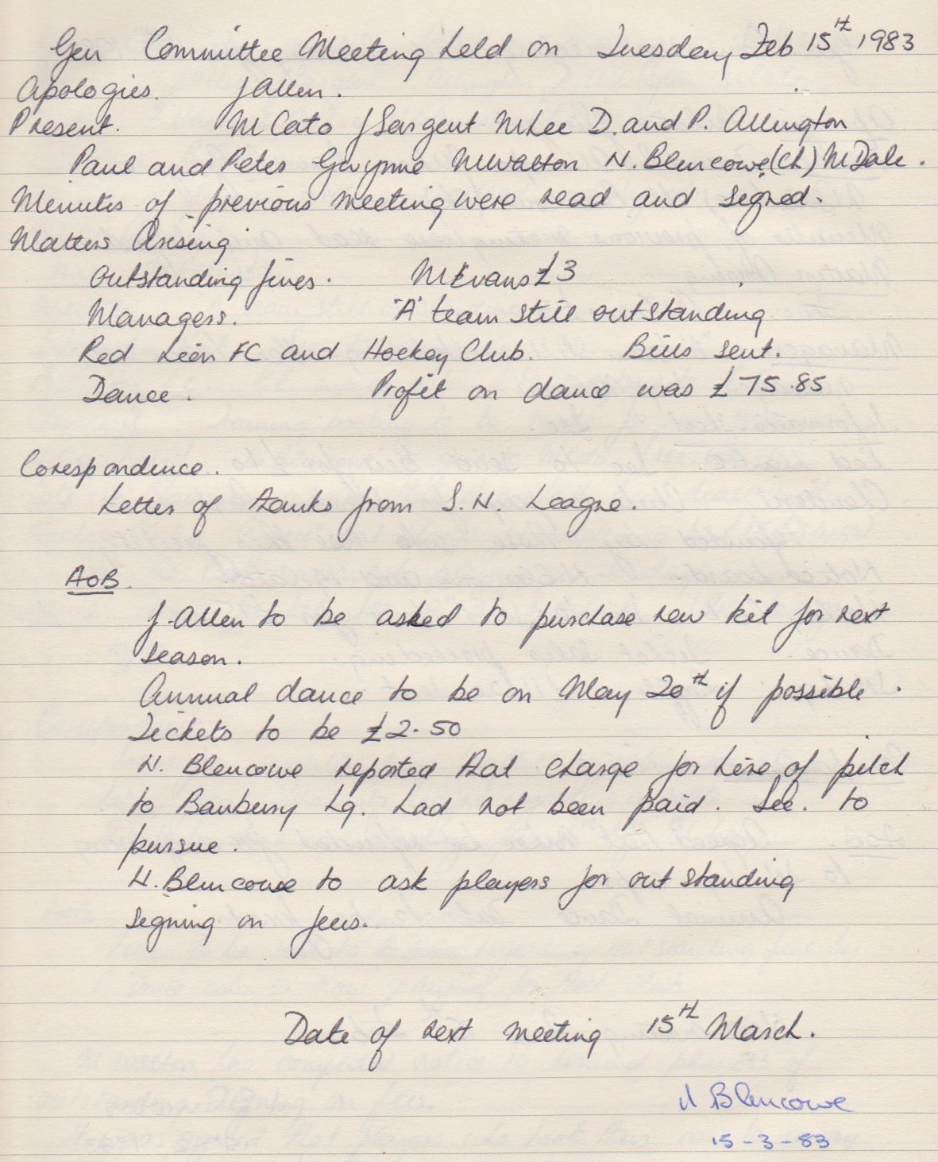

**General Committee Meeting**

**March 15th 1983**

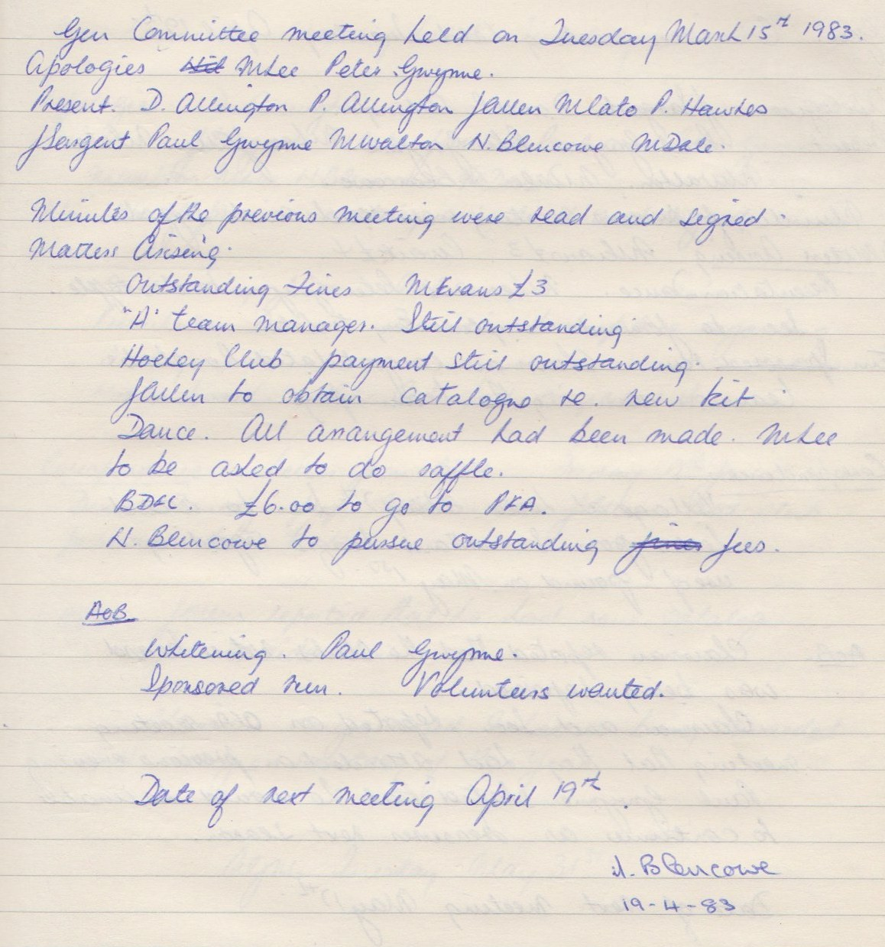

**General Committee Meeting**

**April 19th 1983**

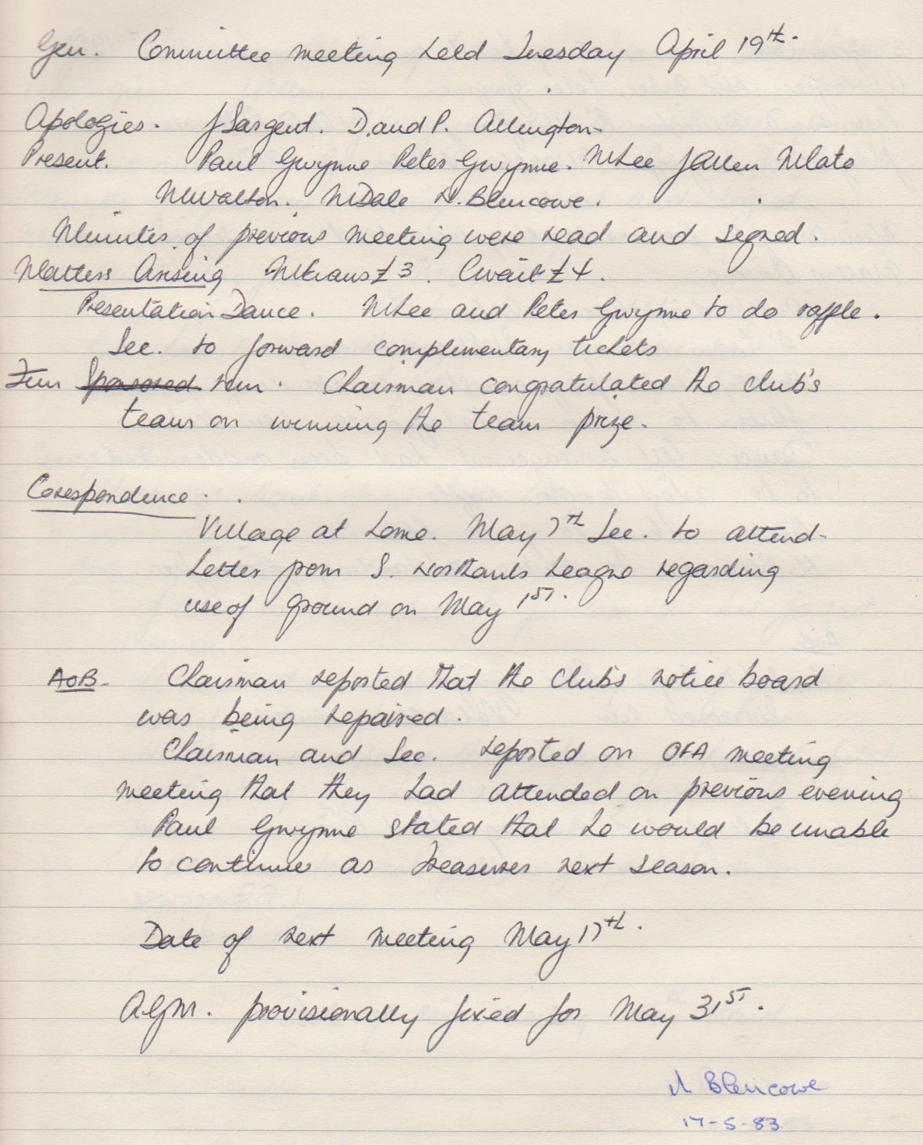

**General Committee Meeting**

**May 17th 1983**

